Module 1 – Overview of IT Industry

1. What is a Program?

A Program is a set of instructions that we give to computer so that it will do a given particular task. A program contains code which is written in any programming language which is compiled into machine readable form and then executed.

* Write a simple "Hello World" program in two different programming languages of your choice.

In C language

#include <stdio.h>  
int main() {  
 printf("Hello, World!\n");  
 return 0;  
}

In Python

print("Hello, World!")

1. What are the key steps involved in the programming process?

The programming process generally involves understand the problem, design a solution, write code, test, and document the program.

1. What are the main differences between high-level and low-level programming languages?

High-level Programming:- It is designed to make it easier for humans to understand and read code. It requires interpreter to convert human language into machine readable code.

Low-level Programming:- It is closer to machine instructions and require more precise control. They are directly executed by CPU so no need for intermediator.

1. Describe the roles of the client and server in web communication.

In web communication, the client initiates requests for services and this requests are of two types GET & POST , while the server responds to those requests by providing the requested content. This a request-response pattern.

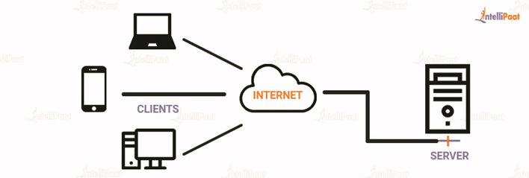

1. Explain the function of the TCP/IP model and its layers.

The TCP/IP model is a four-layer framework that defines how data is transmitted over networks, ensuring reliable communication between devices. It consists of four layers: Application, Transport, Internet, and Network Access (or Physical). Each layer performs specific functions that contribute to the overall communication process.

1. Explain Client Server Communication.

In Client-Server communication clients (typically user applications or devices) request services or data from servers. The server processes these requests and sends back responses.

1. How does broadband differ from fiber-optic internet?

Broadband is a general term for high-speed internet. In contrast, fiber optic internet is a specific type of broadband that uses thin glass or plastic fibers to transmit data, offering faster speeds and lower latency.

1. What are the differences between HTTP and HTTPS protocols?

HTTP (Hypertext Transfer Protocol) is the standard, transmitting data in plain text, while HTTPS (Hypertext Transfer Protocol Secure) is a more secure version of HTTP that encrypts data before transmission. This encryption protects sensitive information like passwords and credit card details from being intercepted. HTTPS provides a secure channel for data transfer, while HTTP does not.

1. What is the role of encryption in securing applications?

Encryption plays a crucial role in application security by ensuring the confidentiality, and authenticity of data. It converts data into an unreadable format (ciphertext) that can only be accessed with the correct key. This protects sensitive information from unauthorized access, even if it's intercepted or stolen.

1. What is the difference between system software and application software?

**System Software:** Manages and controls the computer's hardware and resources. It acts as an interface between hardware and application software. Examples include operating systems (like Windows or Linux), calculator, etc..

**Application Software:** Designed for users to perform specific tasks.  Examples include word processors (like Microsoft Word), web browsers (like Chrome), and image editors (like Photoshop). It interacts directly with the user to perform their desired functions.

1. What is the significance of modularity in software architecture?

Modularity involves breaking down a complex system into smaller, independent modules that can be developed, tested, and deployed separately. This modular approach offers numerous benefits, including improved code organization, enhanced collaboration, increased flexibility, and reduced development time.

Modularization makes code easier to understand, maintain, and update by organizing it into logical, self-contained units.

Modules can be reused in different projects or systems, saving development time and effort.

1. Why are layers important in software architecture?

Layers are like distinct sections or compartments within a software application, each responsible for a specific type of task. This organization helps make software easier to understand, modify, and maintain, as well as enabling independent development and testing.

1. Explain the importance of a development environment in software production.

A development environment is crucial in software production as it provides a controlled, isolated space for developers to build, test, and debug code without impacting the live application or users.

1. What is the difference between source code and machine code?

Source code is the human-readable text written by programmers using a programming language like Python or Java, while machine code is the binary instructions (0s and 1s) that a computer's CPU directly executes.

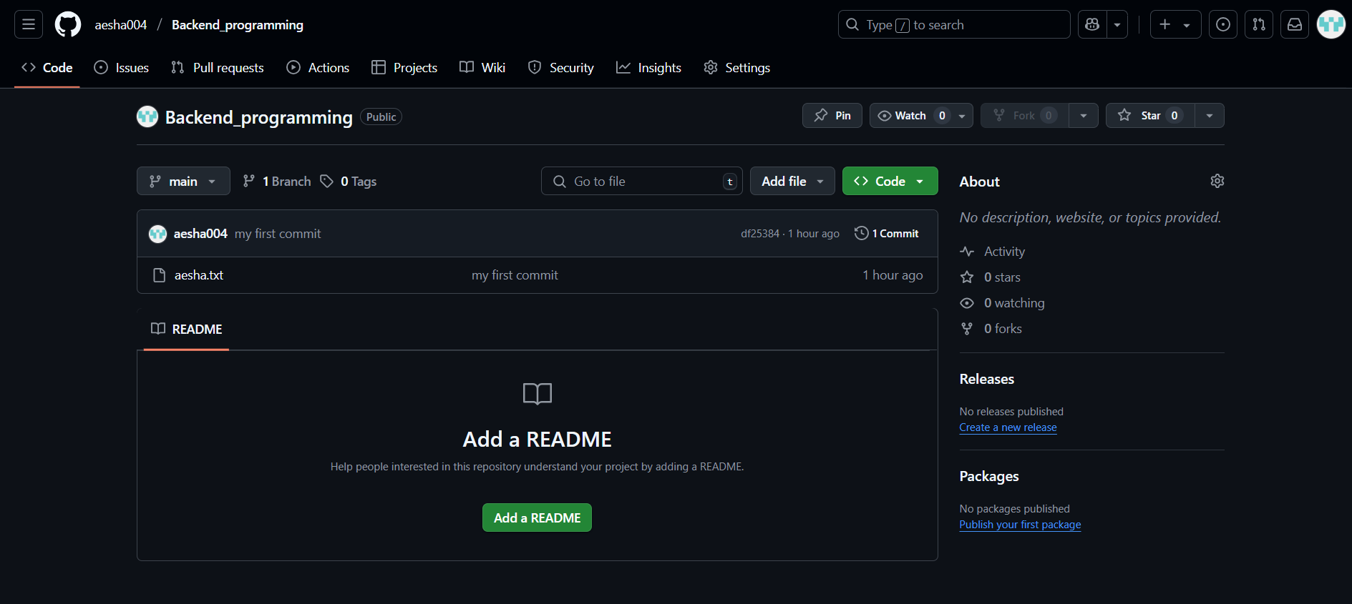

First sample file push to repository

1. What are the benefits of using Github for students?

By using GitHub, students can effectively manage code, track changes, and collaborate with others on projects, ultimately building valuable experience and showcasing their skills.



Created student profile and a repository to work on